INTERNAL Requirements Specification – VVR Minor Enhancements

Date: | 07/03/2025 | Tracker: | EAO051
BA: | Abdon Martinez | Release Number: | 25.2
Developer: | Vivek Kumar | Sprint Number:
Peer Reviewer: | Miguel Marcelo | Customer: | ETNA Supply

Revision History
Date | Version ID | Author | Change
09/5/2025 | 1 | Abdon Martinez | Initial Draft
9/10/2025 | 1 | Miguel Marcelo | Reviewed

***INTERNAL DESIGN SPECIFICATION***

1. Design Requirements
Business Reason

To support a more intuitive and efficient user experience within the VVR functionality, the following minor enhancements are proposed. These changes are driven by direct customer feedback and aim to improve navigability, clarity, consistency, and workflow efficiency across the system.

- Improved Menu Accessibility for “Rebate Group Maintenance”
Users reported difficulty locating the “Rebate Group Maintenance” menu due to the use of a non-intuitive hot key (“0”). By updating the hot key to “A,” which is available and more recognizable, we enhance menu discoverability and reduce time spent navigating the interface. This change supports faster onboarding and reduced training time for new users.

- Add Dollar Format to Reconciliation Variance Percentage Pop-Up
The absence of a dollar format in the variance amount field has led to confusion and potential misinterpretation of financial data. Adding the correct currency format ($xxx.xx) ensures data clarity, reduces errors, and aligns with financial reporting standards.

- Display Vendor Name in Rebate Program View
When users populate rebate programs without selecting a vendor, the lack of vendor identification hinders their ability to verify or cross-reference rebate data. Including the Vendor Name in the default view improves data transparency, contextual awareness, and supports more informed decision-making, especially for new or less experienced users.

- Standardize “Complete” Button Labeling
The inconsistent capitalization of the “ComPlete” button deviates from established UI conventions across Solar screens. Standardizing the label to “Complete” enhances interface consistency, reduces cognitive load, and aligns with user expectations, contributing to a more polished and professional interface.

- Rename Control Record for VVR Variance Percentage
The current control record name “Rebate Variance Percentage” is too generic, making it difficult for users to identify its specific function. Renaming it to “VVR Rebate Variance Percentage” improves searchability, categorization, and administrative efficiency when managing control records.

- Add Completion Notification to Recalculate Variance Process
Users currently lack confirmation when the recalculation of variance process completes, leading to uncertainty and potential delays. Adding a completion prompt or message enhances process transparency, user confidence, and workflow continuity, especially in time-sensitive reconciliation tasks.

- Restore Original Sort Order for Rebate Programs
When moving a rebate program back to the unreconciled list, it currently appears at the bottom, disrupting the original sort order. Restoring it to its original position improves list organization, user control, and efficiency in managing large datasets, particularly for users handling multiple rebate programs.

Design Details

Describe the first part of the slice and include any flow charts showing routines and files.

1.1. Solar Menus / Purchasing > Vendor Volume Rebates Menu

Change the hot key of the Solar Menu "Rebate Gr0up Maintenance", it has zero as hot key, but by checking the MENU~PRICE the A is also available. We will change the hot-key and we will start using the A instead of the Zero, the new menu will look after the change “Rebate Group Maintenance”. For Solar is not needed to uppercase the Hot key.
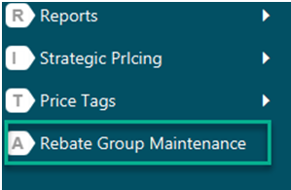

1.1.1. Functionality

After the modification it will allow to find the menu item with the “Search within Solar” as the users type the “Rebate Group” wording.

1.1.2. Design Considerations

Respect the standards to assign the new Menu name

2.1. Vendor Volume Rebates Reconciliation Queue / Pending Variance Prompt on Complete.

- It will be adding the dollars sign to dollars amount displayed in the prompt that is showed up when the user try to click the Complete bottom in the Reconciliation queue.
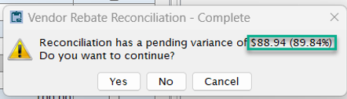

2.1.1. Functionality

  - No functionality Changes more than cosmetic changes.
  - Make sure it continues working as current after this cosmetic change

2.1.2. Design Considerations

  - Add currency signs to amounts

2.2. Vendor Volume Rebates Reconciliation Queue / Standardize Complete Button UI.

- It will be also standardized the wording of the “ComPlete” button which deviates from established UI conventions across Solar screens removing the uppercase letter P to reads “Complete”
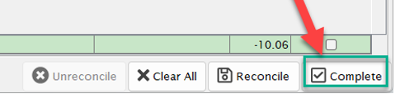

2.2.1. Functionality

  - No functionality Changes more than cosmetic changes.
  - Make sure it continues working as current after this cosmetic change

2.2.2. Design Considerations

  - Respect Standard for UI Design buttons naming

2.3. Vendor Volume Rebates Reconciliation Queue / New View with Vendor Name column

Display Vendor Name in Rebate Program View: When users populate rebate programs without selecting a vendor, the lack of vendor identification hinders their ability to verify or cross-reference rebate data.

2.3.1. Functionality

- It will be added a new Vendor Name View, it will be exactly the same to the existing Main View, but it will have the vendor Name as First Column.
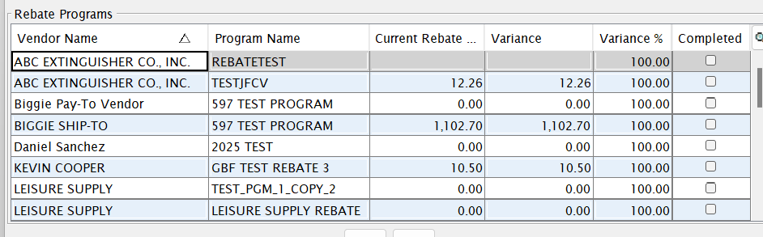

2.3.2. Design Considerations

  - It will continue working the same showing the Main View as the default view.

2.4. Vendor Volume Rebates Reconciliation Queue / Completion Notification to Recalculate Variance Process

Add a completion prompt or message confirmation when the recalculation of variance process is completed.

2.4.1. Functionality

- When the user recalculates the Variance,
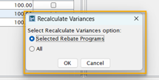

It needs to show up a message of the competition of the process.
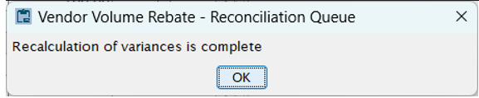

2.4.2. Design Considerations

  - It will continue working the same, but it will show up the notification that the variance calculation has been completed.
2.5. Vendor Volume Rebates Reconciliation Queue / Restore Original Sort Order for Rebate Programs

When moving a rebate program back to the unreconciled list, it currently appears at the bottom, disrupting the original sort order. We need to restore the program to its original position when moved from the Program to Reconcile back to the Rebates Programs List.

2.5.1. Functionality

- When user moves programs between the Rebates Programs section at the middle of the screen and the Rebates Programs to Reconcile Section at the bottom of the screen, when moved back to the Rebates Program section, it should respect the original position respecting the current sort in the Rebates Programs Section.
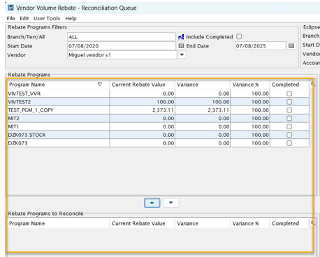

2.5.2. Design Considerations

  - Do not affect performance of the screen

3.1. Vendor Volume Rebates / VVR Variance Percentage Control File

The current control record name “Rebate Variance Percentage” is too generic, making it difficult for users to identify its specific function. Renaming it to “Vendor Volume Rebate Variance Percentage” improves searchability and allow identified as part of the VVR features.

3.1.1. Functionality

Change the Name of the control Record Variance Percentage to Vendor Volume Rabate Variance Percentage
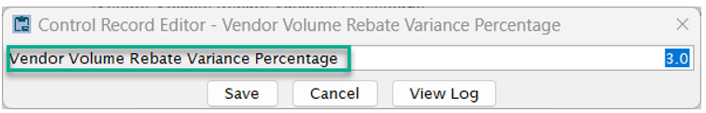

3.1.2. Design Considerations

Respect the Standard Naming for Control Files.

2. Q/A Concerns
If Q/A should have any special notes to help them thoroughly test this enhancement they should be listed here. This should point to key areas that may be broken or changed by this modification throughout the system.

To ensure a thorough and effective QA process, the following areas should be carefully tested:
- Menu Accessibility – Hot Key Change
  - Confirm that the “Rebate Group Maintenance” menu is accessible using the new hot key “A”.
  - Validate that the menu appears correctly in the “Search within Solar” feature.
  - Ensure no conflicts arise with other menu items using the “A” hot key.
- Reconciliation Variance Pop-Up – Dollar Format
  - Verify that all dollar amounts in the variance pop-up are correctly formatted as $xxx.xx.
  - Confirm that no functional behavior is altered by this cosmetic change.
- Vendor Name Column in Rebate Program View
  - Ensure the new view includes the Vendor Name as the first column.
  - Validate that the default view remains unchanged.
  - Confirm data accuracy and alignment in the new column.
- Standardization of “Complete” Button
  - Check that the button label now reads “Complete” across all relevant screens.
  - Ensure the button functionality remains unchanged.
- Completion Notification for Recalculate Variance
  - Confirm that a clear and user-friendly message appears upon completion of the recalculation process.
  - Validate that the message does not interrupt or delay workflow.
- Restore Original Sort Order
  - Test that rebate programs moved back to the unreconciled list return to their original position.
  - Validate that sorting logic is preserved and consistent with user expectations.
- Control Record Renaming
  - Ensure the control record is renamed to “Vendor Volume Rebate Variance Percentage”.
  - Confirm that all references to this control record throughout the system are updated accordingly.
Regression Testing:
QA should also perform regression testing on the Vendor Volume Rebates module to ensure no unintended side effects have been introduced by these enhancements.

3. Support or Release Concerns
If there are specific conversion routines that should be run when a site upgrades to the release that this version will be included on, they should be listed here. In addition, if there are control records, auth keys or other maintenance customers need to worry about, list those here as well.

To support a smooth upgrade and deployment, the following items should be addressed:
- Conversion Routines
  - No data conversion routines are required for these enhancements, as all changes are cosmetic or UI-based.
- Control Records
  - The renamed control record “Vendor Volume Rebate Variance Percentage” should be verified post-upgrade.
  - Ensure that any scripts or reports referencing the old control record name are updated accordingly.
- Authorization Keys
  - No new auth keys are introduced; however, verify that existing permissions allow access to the new Vendor Name view and updated menu hot key.
- Customer Communication
  - Customers should be informed of the updated hot key for “Rebate Group Maintenance”.
  - A brief note should be included in release documentation highlighting the cosmetic changes and the new completion notification.
- Training & Documentation
  - Update internal and customer-facing documentation to reflect:
    - The new hot key Menu assignment.
    - The standardized “Complete” button label.
    - The addition of the Vendor Name View and column.
    - The new completion message behavior.

